ADSR-F15-24 Miniature Through Bore Slip Ring Capsule
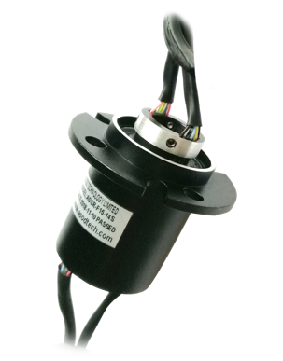
A through bore slip ring is a device which allows the transfer of power, data or video between a stationary part and a rotating part while providing an unobstructed bore through the center for routing space of hydraulics, pneumatics or for a concentric shaft mount. A slip ring consists of conductive ring, insulating ring, brush block, shaft and housing. A slip ring is also called a rotary electrical interface, electrical rotary joint, rotating electrical connector, commutator, collector or swivel. A slip ring can improve system performance by simplifying operations and eliminating damage prone wires.

The ADSR-F15-24 slip ring capsule with through bore is the ideal solution for requiring compact through bore configuration applications. This slip ring provides a 15mm through bore for shaft mounting, 32.8mm outer diameter and 41.73mm short overall length to minimize the mounting space. This 15mm hollow shaft also can be used to mount a single channel coax rotary joint to provide a 24 circuits HD-SDI(1080P) slip ring. 6, 12, 14 and 18 ways configurations optional.

Features
- 24 circuits 2A
- 15mm through bore, 32.8mm outer diameter and 41.73mm length
- Speeds up to 300rpm
- Support various combination of power, signal and data transmission
- Low electrical noise
- Off the shelf and quick shipment

Typical Applications
- Motion control systems
- Eddy current inspection equipment
- Camera systems
- Precision rotary equipment
- Robotics

Specification
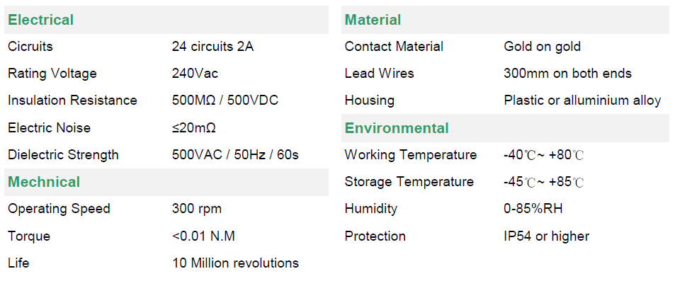

ADSR-F15-24 Dimensions

